CONTAINMENT ZONE ALERTING
APPLICATION

Submitted by
PRADEEP K (720819104087)
SANTHOSH C (720819104098)
SEDHU MADHAVAN K (720819104100)
SURENDHAR R (720819104113)



COMPUTER SCIENCE AND ENGINEERING HINDUSTHAN INSTITUTE OF
TECHNOLOGY
ANNAUNIVERSITY: CHENNAI 600 025

NOVEMBER 2022

PROJECT REPORT FORMAT

- INTRODUCTION
  - Project Overview
  - Purpose
- LITERATURE SURVEY
  - Existing problem
  - References
  - Problem Statement Definition
- IDEATION & PROPOSED SOLUTION
  - Empathy Map Canvas
  - Ideation & Brainstorming
  - Proposed Solution
  - Problem Solution fit
- REQUIREMENT ANALYSIS
  - Functional requirement
  - Non-Functional requirements
- PROJECT DESIGN
  - Data Flow Diagrams
  - Solution & Technical Architecture
  - User Stories
- PROJECT PLANNING & SCHEDULING
  - Sprint Planning & Estimation
  - Sprint Delivery Schedule
  - Reports from JIRA
- CODING & SOLUTIONING (Explain the features added in the project along with code)
  - Feature 1
  - Feature 2
  - Database Schema (if Applicable)
- TESTING
  - Test Cases
  - User Acceptance Testing
- RESULTS
  - Performance Metrics
- ADVANTAGES & DISADVANTAGES
- CONCLUSION
- FUTURE SCOPE
- APPENDIX
Source Code
GitHub & Project Demo Link

1. INTRODUCTION:
1.1) PROJECT OVERVIEW:
This application is intended to provide information about containment zones in a particular region by alerting people, through continuous monitoring of an individual's location. Key benefits of the application are monitoring people's activity and alerting them to their safety movements. Currently there are several research works undergoing in the country to prevent Covid-19 cases from rising. Previously our country was importing medical kits like PPE (Personal Protection Kits), mask from outside, but now it has been successful in developing these kits. Along with taking initiatives to fight this disease, our country has also taken steps to make people aware of the disease. The news and media have a great part in creating this awareness by informing the public about the preventive measures that can keep them away from infection. Awareness among the people to carry out all the preventive measures can immensely help to reduce spread of the virus. The country has created containment zones throughout the cities wherever Covid-19 cases have been reported to prevent further spread of the virus. These containment zones have been kept isolated from the outside public to ensure no contamination occurs outside. After more than 2 months of the lockdown, the government has relaxed some of the lockdown rules and has permitted reopening of government offices, bus and other road transportation facilities and shopping markets. People can move inside the city for work and other purposes. But the containment zones are still being kept isolated, and new containment zones are being formed wherever Covid-19 cases have been reported. These zones are highly contagious as droplets with virus coughed out from an unscreened asymptomatic patient can travel up to 8 m (Bahl et al. 2020). Though these containment zones are guarded by policemen, still there remains a chance that people might unknowingly step into them. In this situation where people can move in the city, these containment zones pose a risk of infection to these city dwellers. Therefore, informing people about the location of the containment zones can help them bypass and avoid these zones and thereby reduce the chance of community transmission. In this paper, we focus on developing a mobile based application to provide information regarding the Covid-19 containment zones in West Bengal. The application further tracks the user’s location and provides notification alert if the user has entered a containment zone. The application also provides daily Covid-19 case statistics to the users to keep them updated. The application is developed on Android SDK and uses Firebase Cloud Firestore to store the location data. Android’s geofencing client is used to create geofences around the containment zones and notification manager is used to provide notifications. The application also uses RESTful web services to show the Covid-19 cases in West Bengal. We have tested our application with different users in different locations across West Bengal and it works efficiently and is able to attain our target.

1.2) PURPOSE:
The project aims at building an application that provides information about the containment zones of a particular region by continuously monitoring an individual's location. The location of the individual must be stored in the Database. Alerts are sent using the notification service.

2. LITERATURE SURVEY:
2.1) EXISTING PROBLEM:
People doesn’t have proper knowledge about containment zones since they do change daily and hard to keep updated and if they are not updated properly, they will lead to wide spread of disease.

2.2) REFERENCES:
Name of the paper:
Development of An Android Application for Viewing Covid19 Containment Zones and Monitoring Violators Who are Trespassing into It Using Firebase and Geofencing.
Author:
Ranajoy Mallik- Jadavpur University
Amlan Protim Hazarika-Jadavpur University
Sudarshana Ghosh Dastidar- Jadavpur University
Dilip Sing- Jadavpur University
Rajib Bandyopadhyay- Jadavpur University
Published Online:
1 July 2020
Topic:
Containment Zone Alerting Application
Theme:
Our theme of the project is to provide information about containment zones in a particular region by alerting people, by continuously monitoring an individual's location. Key benefits of the application are monitoring people's activity and alerting them of their safety movements.

Overall inference:
The country has created containment zones throughout the cities wherever Covid-19 cases have been reported, to prevent further spread of the virus. These containment zones have been kept isolated from the outside public to ensure no contamination occurs outside. Though these containment zones are guarded by policemen, still there remains a chance that people might unknowingly step into them. In this situation where people can move in the location of the containment zones can help them bypass and avoid these zones and thereby reduce the chance of community transmission to the city, these containment zones pose a risk of infection to these city dwellers.
Therefore, informing people about the location of the containment zones can help them bypass and avoid these zones and thereby reduce the chance of community transmission. So, our aim is to develop an application that tracks the user's location and provides a notification alert if the user has entered a containment zone. The application provides daily Covid-19 case statistics to the users to keep them updated.
Most of the states of our country have their own apps with specific features and functionality to help their citizens to stop COVID-19 spread, get medical assistance during a crisis, create awareness, and understand safety precautions.
The study shows that there are a limited number of apps that show the COVID-19 containment zones in the country or state and out of these none has the functionality of notifying and alerting the user when they have entered a containment zone.
The application shows the location of the containment zones to the users. It also notifies the user when he or she trespasses the geofence of a containment zone or stays in the containment zones.
Name of the paper:
Mobile Health Apps That Help With COVID-19 Management: Scoping Review
Author:
Tracie Risling and Gunther Eysenbach
Published Online:
Aug 2020
Topic:
COVID-19 Management Application
Theme:
Our theme is to scope the evidence base on apps that were developed in response to COVID-19.

Overall inference:
Mobile health (mHealth) apps have played an important role in mitigating the coronavirus disease (COVID-19) response. However, there is no resource that provides a holistic picture of the available mHealth apps that have been developed to combat this pandemic
This review identifies that the majority of COVID-19 apps were for contact tracing and symptom monitoring. However, these apps are effective only if taken up by the community. The sharing of good practices across different countries can enable governments to learn from each other and develop effective strategies to combat and manage this pandemic.
Name of the paper:
COVID19-Tracker: A shiny app to produce to produce comprehensive data visualization for SARS-CoV-2 epidemic in Spain.
Author:
- Aurelio Tobias-Institute of Environmental Assessment and Water Research I IDAEA • Geosciences
- Cristian Tebe-Bellvitge Biomedical Research Institute
- Joan valls
- Pau Satorra
Published Online:
April 2020
Topic:
Containment Zone Alerting Application
Theme:
Our theme of the project is to provide information about containment zones in a particular region by alerting people, by continuously monitoring an individual's location. Key benefits of the application are monitoring people's activity and alerting them of their safety movements.
Overall inference:
Data visualization is an important tool for exploring and communicating findings in medical research, and specially in epidemiological surveillance.
The COVID19-Tracker app systematically produces daily updated data visualization and analysis of SARS-CoV2 epidemic in Spain.
It collects automatically daily data on COVID-19 diagnosed cases, intensive care unit admissions, and mortality, from February 24th, 2020 onwards. Two applications have already been developed,
- To analyze data trends and estimating short-term projections and
- To assess the effect of the lockdown on the trend of incident data.
The plan is to improve the app by uploading shortly new applications for data visualization and analysis, which may help for a better understanding of the SARS-CoV-2 epidemic data in Spain.
Data visualization is an important tool for exploring and communicating findings in medical research, and specially in epidemiological surveillance. It can help researchers and policy makers to identify and understand trends that could be overlooked if the data were reviewed in tabular form. We have developed a Shiny app allows users to evaluate daily time-series data from a statistical standpoint. The COVID19-Tracker app systematically produces daily updated data visualization and analysis of SARS-CoV-2 epidemic data in Spain. It is easy to use and fills a role in the tool space for visualization, analysis and exploration of epidemiological data during this particular scenario.
Name of the project:
Containment Plan Novel Coronavirus Disease 2019 (COVID 19)
Author:
- Aurelio Tobias-Institute of Environmental Assessment and Water Research I IDAEA • Geosciences
- Cristian Tebe-Bellvitge Biomedical Research Institute
- Joan Valls

ABSTRACT:
Coronaviruses are large group of viruses that cause illness in humans and animals. Rarely, animal coronaviruses can evolve and infect people and then spread between people such as has been seen with MERS and SARS. Although most human coronavirus infections are mild, the epidemics of the severe acute respiratory syndrome coronavirus (SARS-CoV) and Middle East respiratory syndrome coronavirus (MERSCoV), have caused more than 10,000 cumulative cases in the past two decades, with mortality rates of 10% for SARSCOV and for MERSCoV.
Global Scenario As on 14th May, 2020, COVID-19 confirmed cases are being reported from 214 countries/territories/areas. A total of 42,48,389 laboratory confirmed cases and 2,92,046 deaths have been reported from globally. Focus of outbreak that was initially China, has now shifted to European region and United States of America.

PUBLISHED:
Version 2 (updated 16.05.2020)
Local transmission of COVID-2019 disease:
The strategy will remain the same as explained in para 2.1 as above. In addition, cluster containment strategy will be initiated with:
- Active surveillance in containment zone with contact tracing within and outside the containment zone.
- Expanding laboratory capacity for testing all suspect samples, close contacts, ILI and SARI
•Establishing surge capacities for isolating all suspect / confirmed cases for clinical management.
- Implementing social distancing measures.
- Intensive risk communication.
Deployment of Rapid Response Teams (RRT) State will deploy its state RRT and district RRT teams to undertake mapping of cases and contacts so as to delineate the containment and buffer zones.
Emergency Medical Relief (EMR) division, Ministry of Health and Family Welfare may deploy the Central Rapid Response Team (RRT) to support and advice the State.

2.3) PROBLEM STATEMENT DEFINITION:
Who does the problem affect? | People who are traveling to places being unaware of COVID Containment Zones.
What is the issue? | If people get into a COVID containment zone, there arises a high risk for them getting into contact with an affected person and thereby it results in the transmission of the disease.
When does the issue occur? | When a healthy person gets into contact with an affected person living in a COVID prone area.

People travel to different places unaware of the fact that it is a COVID-19 containment zone and hence don’t take necessary precautions. As a result, the people getting inside a containment zone are at a higher risk of getting affected by the disease.
I am A common man | I’m trying to  Be safe from COVID19 | But I don’t know where to go and where not to. | Because I am not aware of the Containment  Zones | Which makes me feel Anxious &  fearful

Where does the issue occur? | Getting affected by COVID might occur anywhere. Nonetheless, the risk of getting affected by the disease would be very high in Containment Zones.
Why is it important that we fix the problem? | It is important that we fix the problem that people become aware of Containment Zones  and stay away from them to protect themselves from COVID.
What solution to solve this issue? | An Alerting application that delivers instant alerts whenever a person enters a COVID Containment Zone.
What methodology used to solve the issue? | Geofencing of Containment Zones, Constant location monitoring of the users of the application, and instant alert delivery

3) IDEATION & PROPOSED SOLUTION:
3.1) EMPATHY MAP CANVAS:
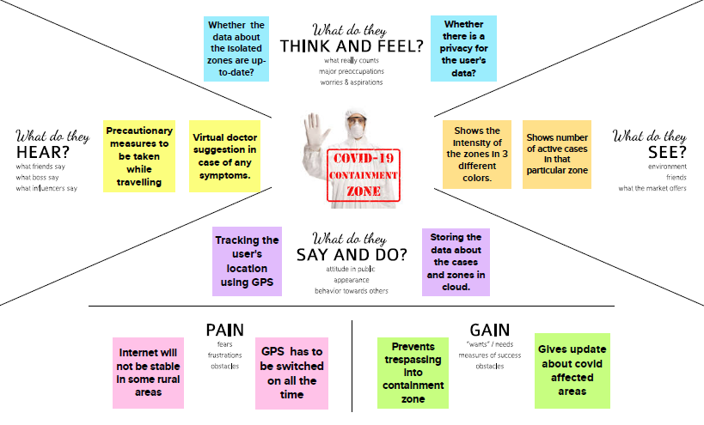
3.2) IDEATION & BRAINSTORMING:
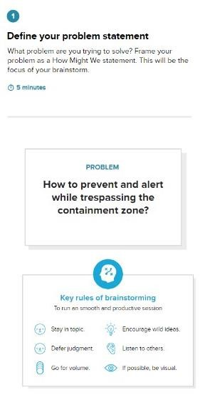

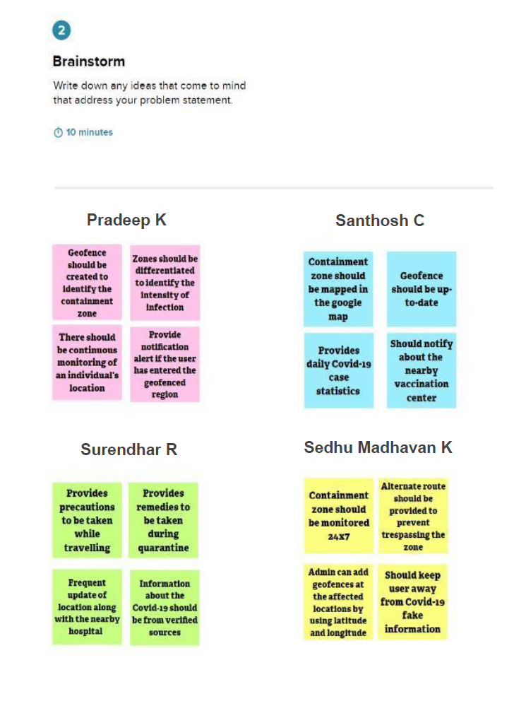

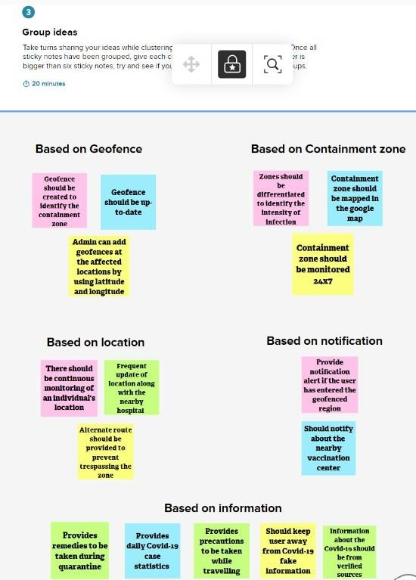

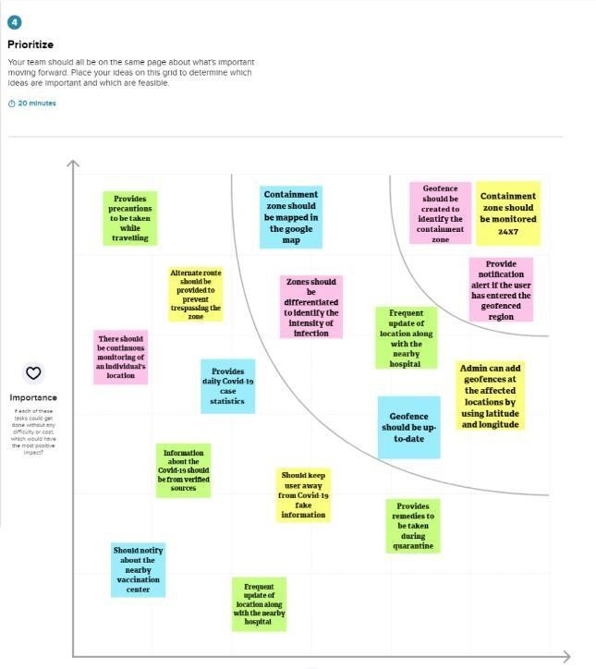

3.3) PROPOSED SOLUTION:
Project team shall fill the following information in proposed solution template.
S.No | Parameter | Description
1. | Problem Statement (Problem to be solved) | To develop an application to notify the users while trespassing the containment zone.
2. | Idea / Solution description | This application provides information about containment zones in a particular region and alerts people, through continuous monitoring of an individual's location.
3. | Novelty / Uniqueness | - Containment zones are differentiated using different colors to identify the intensity of infection.  - Updating containment zone location and creating geofence within a 100-meter radius.
4. | Social Impact / Customer  Satisfaction | - Providing precautions to be taken while traveling.  - Frequently updating the location along with the nearby hospital.
5. | Business Model (Revenue  Model) | Online healthcare services have been incorporated to provide remedies to be taken while quarantining.
6. | Scalability of the Solution | - The radius of the geofence can be increased by 150 to 200 meters.  - Using an IP address to track the user even if the wi-fi or GPS gets turned off.

3.4) PROBLEM SOLUTION FIT:
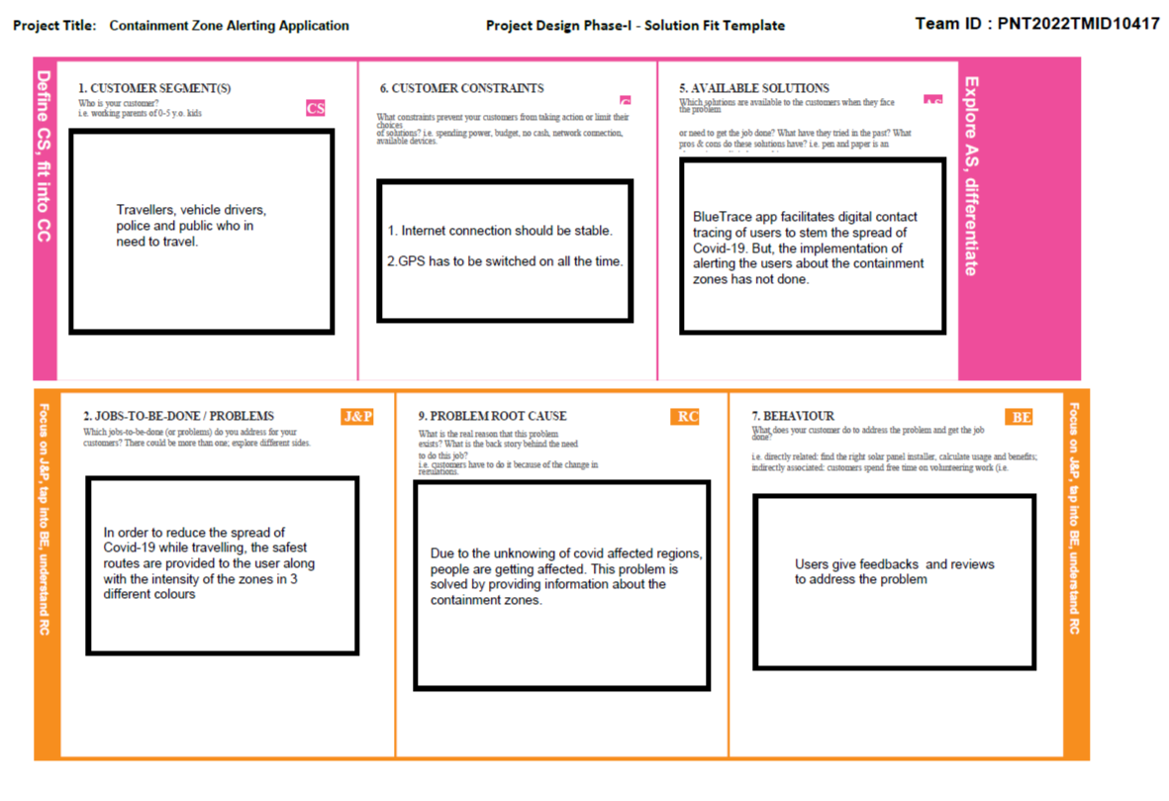

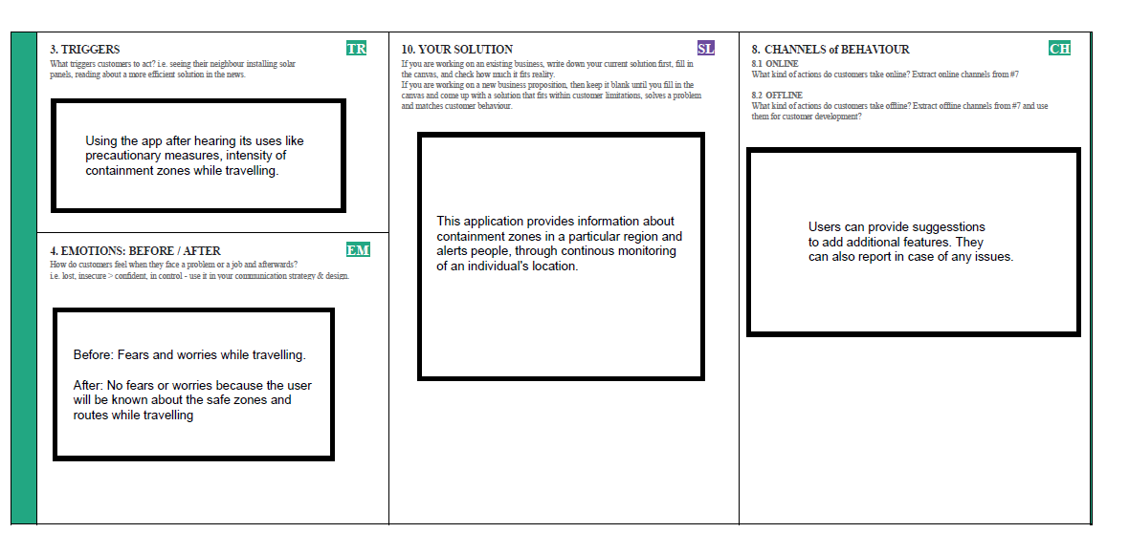
4) REQUIREMENT ANALYSIS:
4.1) FUNCTIONAL REQUIREMENT:

Functional Requirements:
Following are the functional requirements of the proposed solution.
FR  No. | Functional Requirement  (Epic) | Sub Requirement (Story / Sub-Task)
FR-1 | User Registration | It can be registered by a valid phone number or email id.
FR-2 | User Confirmation | A verification code can be received by registering a phone number or mail id.
FR-3 | Notification Alert | Through phone number or email id if user enters the containment zone.
FR-4 | Show Containment Zone | It shows different color virtual boundaries.

4.2) NON-FUNCTIONAL REQIIREMENT:
Following are the non-functional requirements of the proposed solution.
FR No. | Non-Functional Requirement | Description
NFR-1 | Usability | Application updates the location of the areas in a Google map which are identified to be the containment zones
NFR-2 | Security | The data collected from the user is stored securely.
NFR-3 | Reliability | The user can trust the result and navigate safely.
NFR-4 | Performance | The accurate result can be achieved due to realtime location sharing.
NFR-5 | Availability | Available if the network bandwidth of the user is of good range.
NFR-6 | Scalability | The application can be used from anywhere and can also be implemented for both mobile and web apps for the user to interact.

5) PROJECT DESIGN:
5.1) DATA FLOW DIAGRAMS:
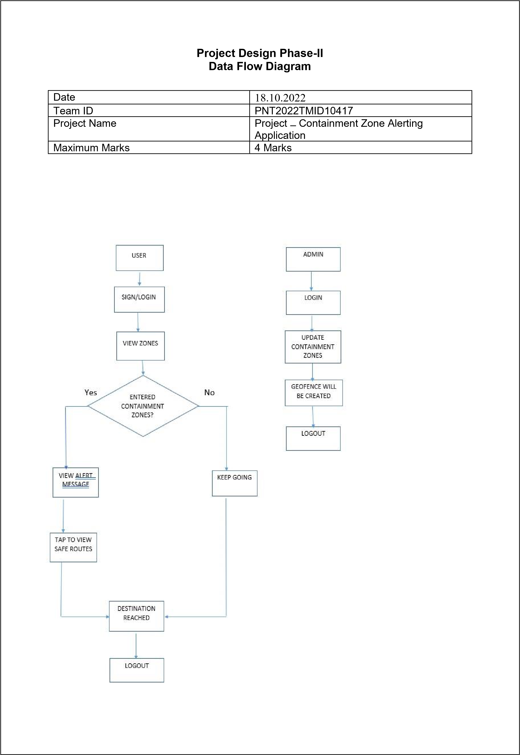

5.2) SOLUTION & TECHNICAL ARCHITECTURE:

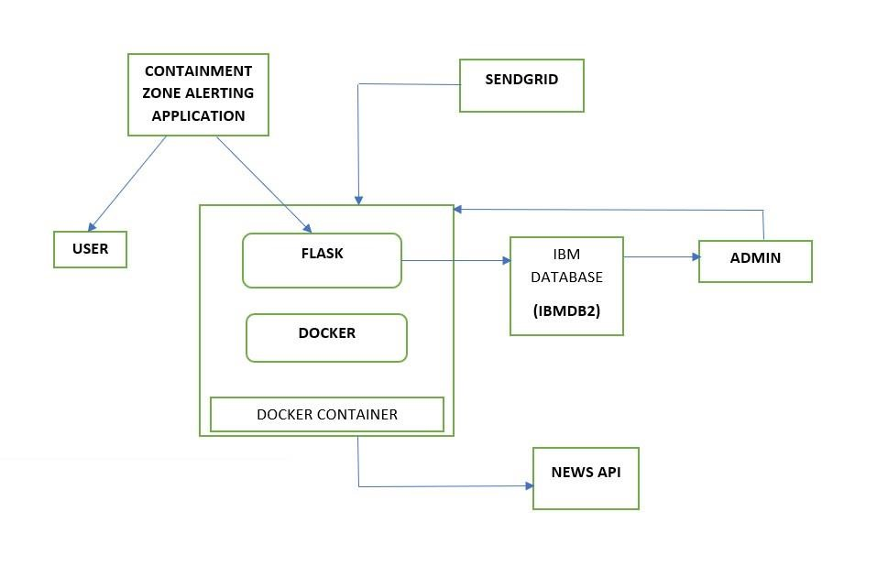
Table-1: Components & Technologies:
S.No | Component | Description | Technology
1. | User Interface | The user interacts with the containment zone alerting application through GUI. | HTML, CSS, JavaScript
2. | Application Logic | Handles API request and serve data by fetching from DB | Docker container
3. | Cloud Database | Stores user data and details of the containment zone | IBM DB2
4. | External API-1 | Scraps Covid-19 updates from websites | NEWS API
5. | External API-2 | Sends e-mail notifications | SendGrid
6. | Infrastructure (Server / Cloud) | Application Deployment on Cloud | Kubernetes

5.3) USER STORIES:
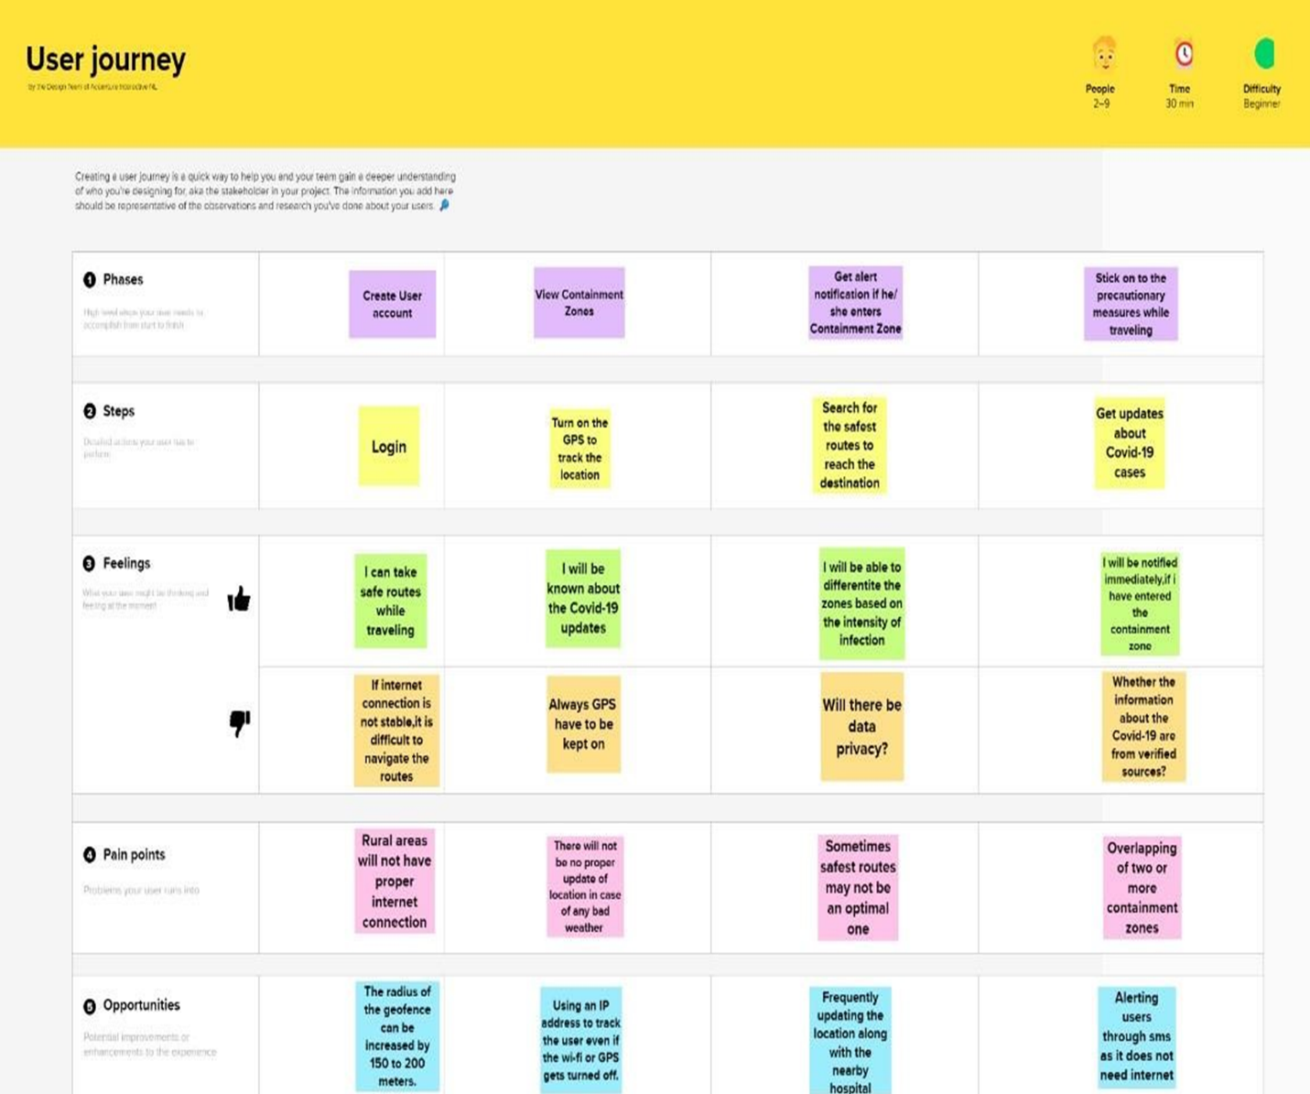
6) PROJECT PLANNING & SCHEDULING:
6.1) SPRINT PLANNING & ESTIMATION:
Sprint | Functional  Requirement  (Epic) | User Story  Number | User Story / Task | Story Points | Priority | Team Members
SPRINT-1 | Registration | USN-1 | USER:  I can register for the application by entering my email and password | 3 | High | Pradeep K  Santhosh C  Sedhu Madhavan K  Surendhar R
 |  | USN-2 | USER:  I will receive a confirmation email once I have registered for the application | 2 | High | Pradeep K  Santhosh C  Sedhu Madhavan K  Surendhar R
 | Login | USN-3 | USER:  I can log into the application by entering my email & password | 3 | High | Pradeep K  Santhosh C  Sedhu Madhavan K  Surendhar R
Sprint | Functional  Requirement  (Epic) | User Story  Number | User Story / Task | Story Points | Priority | Team Members
SPRINT-2 | Dashboard | USN-4 | USER:  I need to give permission to access my location | 5 | High | Pradeep K  Santhosh C  Sedhu Madhavan K  Surendhar R
 |  | USN-5 | USER:  I can view the map with the containment zones | 5 | High | Pradeep K  Santhosh C  Sedhu Madhavan K  Surendhar R
 | Service | USN-6 | ADMIN:  I need to update the containment zones. | 5 | High | Pradeep K  Santhosh C  Sedhu Madhavan K  Surendhar R

Sprint | Functional  Requirement  (Epic) | User Story  Number | User Story / Task | Story Points | Priority | Team Members
SPRINT-3 | Service | USN-7 | ADMIN:  I need to differentiate the containment zones based on the intensity of infection. | 3 | Medium | Pradeep K  Santhosh C  Sedhu Madhavan K  Surendhar R
 |  | USN-8 | ADMIN:  I need to provide precautionary measures when they travel. | 3 | Medium | Pradeep K  Santhosh C  Sedhu Madhavan K  Surendhar R
 |  | USN-9 | ADMIN:  I need to provide information about the nearby hospitals | 3 | Low | Pradeep K  Santhosh C  Sedhu Madhavan K  Surendhar R
Sprint | Functional  Requirement  (Epic) | User Story  Number | User Story / Task | Story Points | Priority | Team Members
SPRINT-4 | Service | USN-10 | ADMIN:  I need to alert the user when they enter the containment zone through email or SMS | 5 | High | Pradeep K  Santhosh C  Sedhu Madhavan K  Surendhar R
 |  | USN-11 | ADMIN:  I need to provide medical recommendations by collaborating with hospitals. | 3 | Low | Pradeep K  Santhosh C  Sedhu Madhavan K  Surendhar R
 | Data collection | USN-12 | ADMIN:  I need to store user details on the cloud | 5 | High | Pradeep K  Santhosh C  Sedhu Madhavan K  Surendhar R
 |  | USN-13 | ADMIN:  I need to collect details about covid-19 cases from verified sources | 5 | High | Pradeep K  Santhosh C  Sedhu Madhavan K  Surendhar R

Velocity:
Imagine we have a 10-day sprint duration, and the velocity of the team is 20 (points per sprint). Let’s calculate the team’s average velocity (AV) per iteration unit (story points per day)
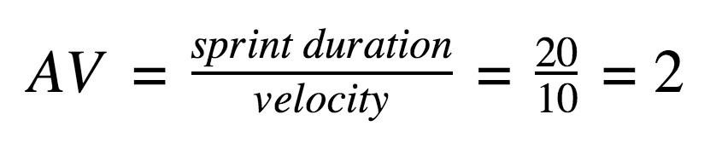
Burndown Chart:
A burndown chart is a graphical representation of work left to do versus time. It is often used in agile software development methodologies such as Scrum. However, burn-down charts can be applied to any project containing measurable progress over time.

6.2) Sprint Delivery Schedule:
Sprint | Total Story Points | Duration | Sprint Start Date | Sprint End Date  (Planned) | Story Points  Completed (as on  Planned End  Date) | Sprint Release Date  (Actual)
Sprint-1 | 20 | 6 Days | 24 Oct 2022 | 29 Oct 2022 | 20 | 29 Oct 2022
Sprint-2 | 20 | 6 Days | 31 Oct 2022 | 05 Nov 2022 | 20 | 05 Nov 2022
Sprint-3 | 20 | 6 Days | 07 Nov 2022 | 12 Nov 2022 | 20 | 12 Nov 2022
Sprint-4 | 20 | 6 Days | 14 Nov 2022 | 19 Nov 2022 | 20 | 19 Nov 2022

6.3) Reports from JIRA:
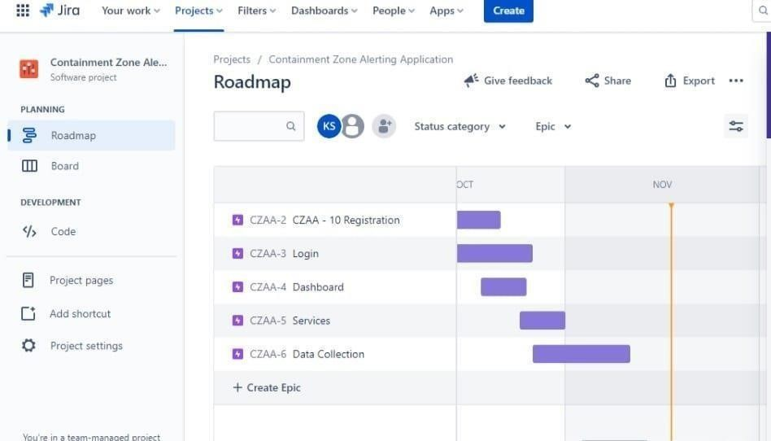
7) CODING & SOLUTIONING:
7.1) Feature 1:
<!DOCTYPE html>
<html lang="en">

<head>
<meta charset="UTF-8">
<meta http-equiv="X-UA-Compatible" content="IE=edge">
<meta name="viewport" content="width=device-width, initial-scale=1.0">
<title>Zones</title>
<link rel="stylesheet" href="https://stackpath.bootstrapcdn.com/bootstrap/4.4.1/css/bootstrap.min.css"
integrity="sha384-Vkoo8x4CGsO3+Hhxv8T/Q5PaXtkKtu6ug5TOeNV6gBiFeWPGFN9MuhOf23Q9Ifjh" crossorigin="anonymous" />
<style>
body {
padding-top: 30px;
padding-bottom: 30px;
background-color: #699cc5;
}

a {
color: black;
}
</style>
</head>

<body>
<div class="m-4 container">
<h1><u>Location data and Visited People</u></h1>
</div>
<div class="m-4 container">
<table class="table">
<thead>
<tr>
<th scope="col">S.No</th>
<th scope="col">Latitude</th>
<th scope="col">Longitude</th>
<th scope="col">No_Visited</th>
</tr>
</thead>
<tbody>

{%- for row in responses %}
<tr>
<th scope="row">{{loop.index}}</th>
<td>{{row[1]}}</td>
<td>{{row[2]}}</td>
<td>{{row[3]}}</td>
</tr>
{%- endfor %}
</tbody>
</table>
</div>
<div class="m-3 float-right">
<button type="button" class="btn btn-danger"><a href={{url_for("home")}}>Go to location update Page</a></button>
</div>

</body>

</html>

7.2) Feature 2:
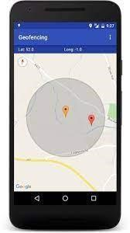

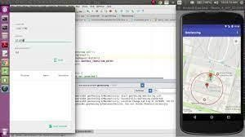

8) TESTING
8.1) Test Cases:
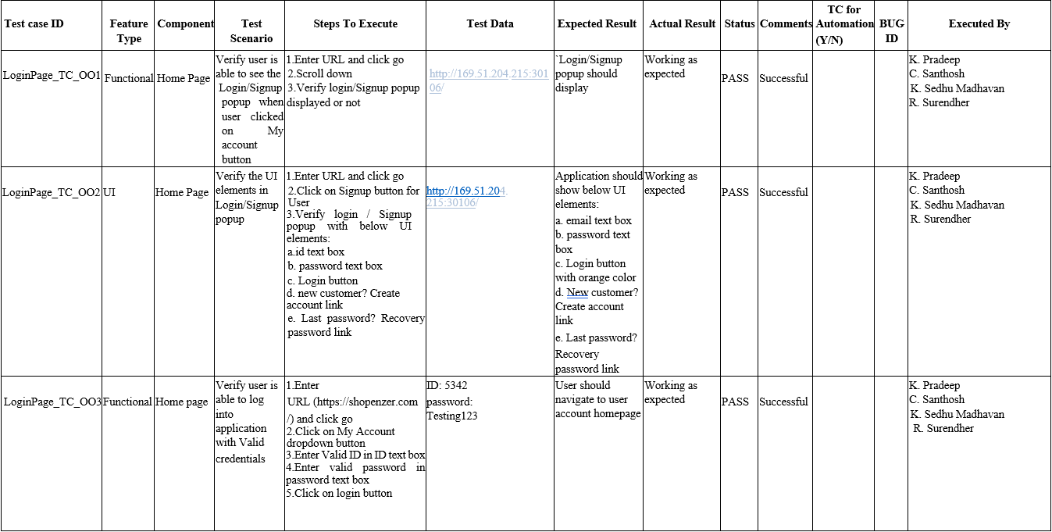
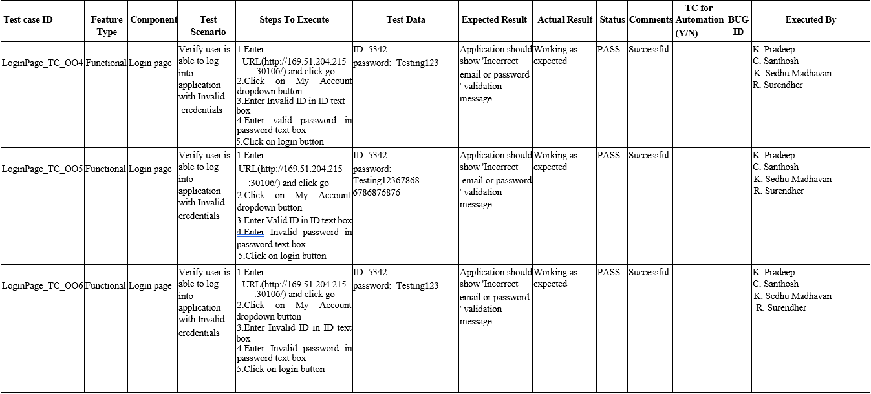
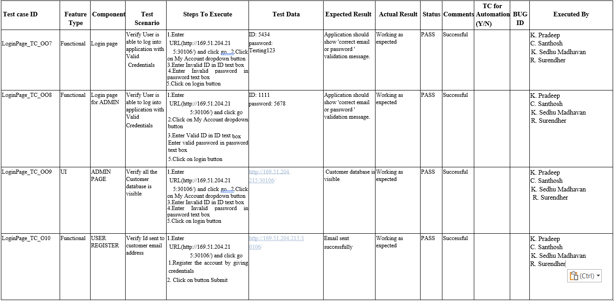
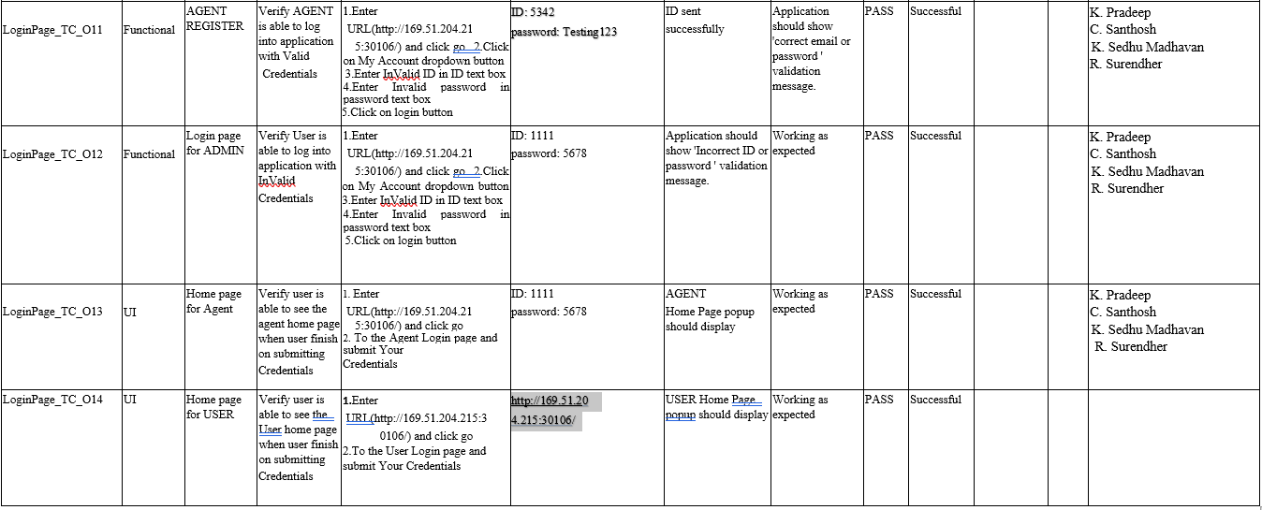
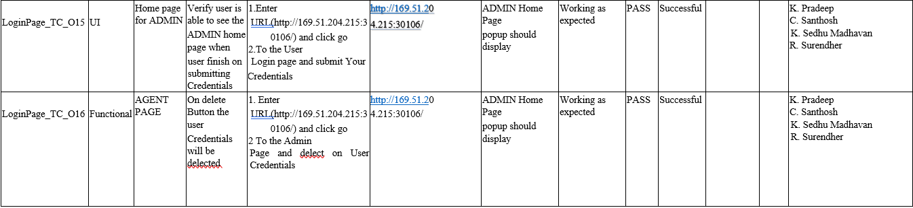
8.2) User Acceptance Testing:
Purpose of document

The purpose of this document is to briefly explain the test coverage and open issues of the [CONTAINMENT ZONE ALERTING] project at the time of the release to User Acceptance Testing (UAT).

Defect analysis

This report shows the number of resolved or closed bugs at each severity level, and how they were resolved

Resolution | Severity 1 | Severity 2 | Severity 3 | Severity 4 | Subtotal
By Design | 10 | 3 | 1 | 2 | 17
Duplicate | 1 | 0 | 3 | 0 | 4
External | 2 | 3 | 0 | 1 | 6
Fixed | 11 | 2 | 4 | 20 | 40
Not Reproduced | 0 | 0 | 1 | 0 | 1
Skipped | 0 | 0 | 1 | 1 | 2
Won't Fix | 0 | 5 | 2 | 1 | 8
Totals | 24 | 13 | 12 | 25 | 78

Test case analysis

This report shows the number of test cases that have passed, failed, and untested

Section | Total Cases | Not Tested | Fail | Pass
Print Engine | 10 | 0 | 0 | 10
Client Application | 50 | 0 | 0 | 50
Security | 2 | 0 | 0 | 2
Outsource Shipping | 3 | 0 | 0 | 3
Exception Reporting | 8 | 0 | 0 | 8
Final Report Output | 4 | 0 | 0 | 4
Version Control | 2 | 0 | 0 | 2

9) RESULTS:
9.1 Performance metrics :
This app service monitors the location and provide information about the contaminated zones near a particular user and send notification to the user. It displays the contaminated zone area by geofencing the particular location.
UI Interact with Application:
Admin App:
Login Page:

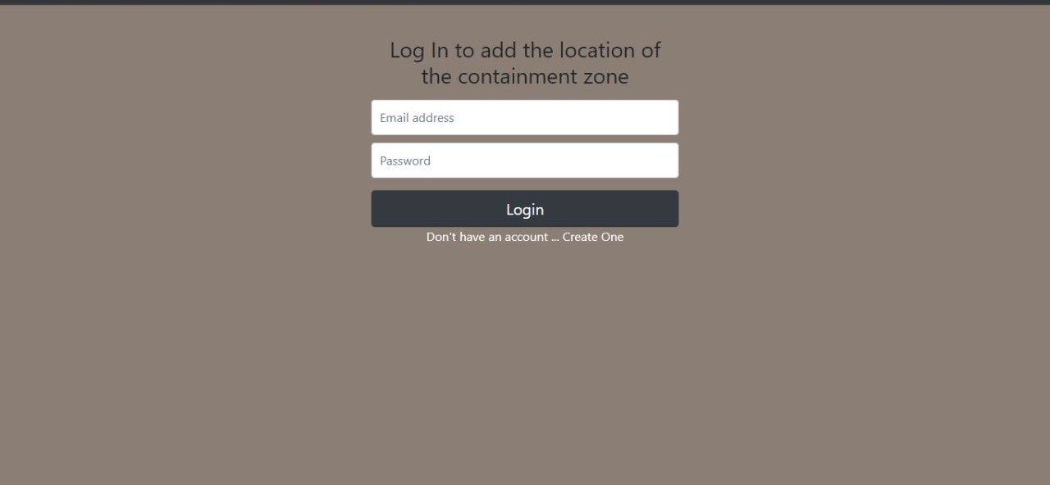

Register page:

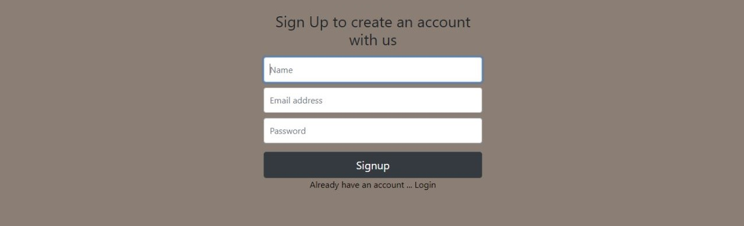
Home page:

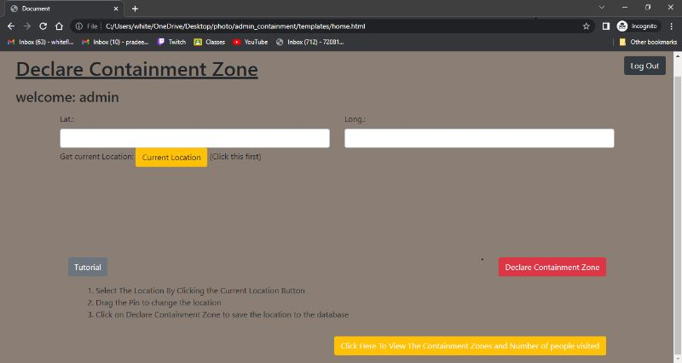

Client Application:
Register screen:

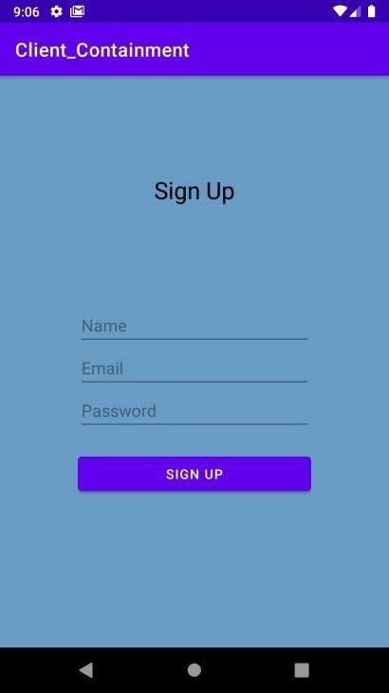

Current Location:

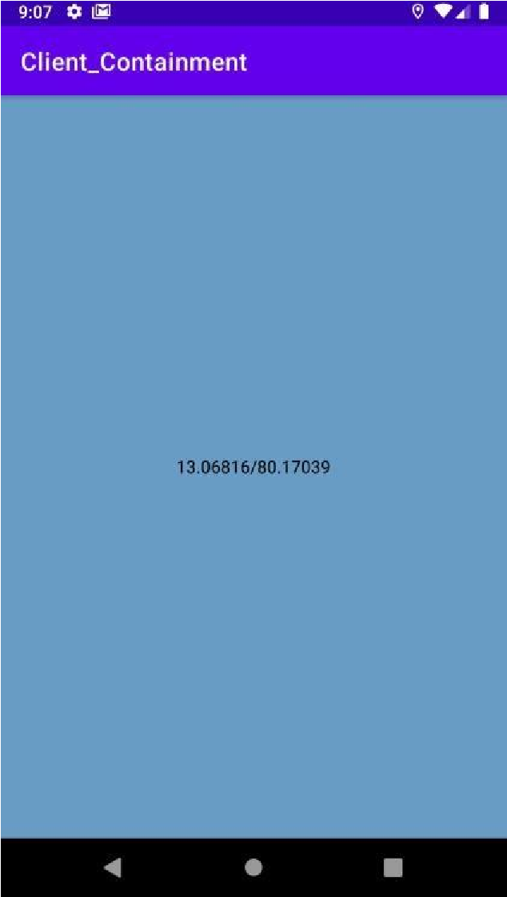

An Email will be sent to the registered mail id if the location is within 100 meters of the locations present in the admin app
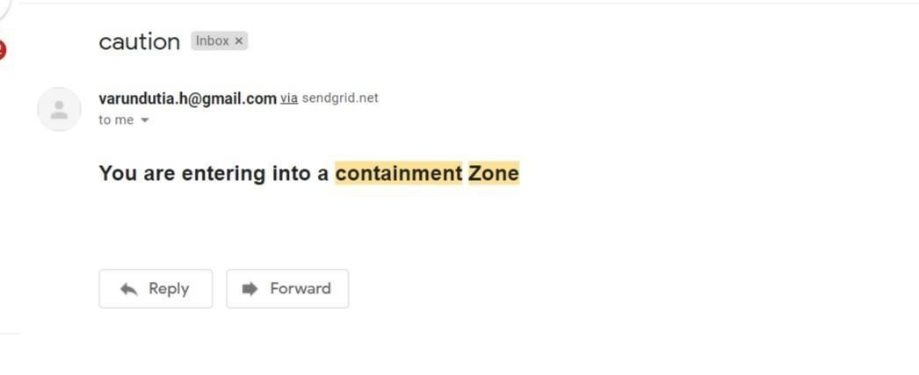

10) ADVANTAGES & DISADVANTAGES:
ADVANTAGES:
• People can be alerted before entering containment zone.
• Further spread of virus can be reduced considerably.

DISADVANTAGES:
• Accuracy of application depends on the number of data given to the application. PNT2022TMID48441
• Application’s accuracy is directly proportional to the number of data given to the application about the infected patients
11) CONCLUSION:
This application is intended to provide information about containment zones in a particular region by alerting people, through continuous monitoring of an individuals location. Key benefits of the application are monitoring peoples activity and alerting them to their safety movements.
12.FUTURE SCOPE:
Although we tried to cover almost all of the aspects during our developmental phase, however we were forced to leave some aspects because of lack of time as well as monetary and other reasons. Just like in the field of software development where there are always some shortcomings and room for improvement our application can be enhanced further: -

1) The application can include various government organization to help act faster.
2) The dataset obtained from the application can be used for predictive analysis to determine prone areas and include special method for tackling the problem in those areas.
3) Emergency signal in case of network failure and internet connection loss.
4) Tackling victim’s movements.
5) Improved Google positioning system’s precision.
6) The client part of application can be integrated in a single intelligent device.

For analysis purpose, we could use machine learning (ML) algorithms as well as data mining applications. There is a sub branch of machine learning known as time series analysis (TSA), which could be used to predict and analyze the data obtained through this application. Time series analysis is used to predict crop production as well as sales in different quarter.

13.APPENDIX:
Source Code:
APP.PY
# import statements
from logging import error
from flask import *
from jinja2.utils import select_autoescape
import bcrypt
from flask_mysqldb import MySQL
import json
from sendgrid import SendGridAPIClient
from sendgrid.helpers.mail import Mail

# initialization
app = Flask(__name__)

# config
app.secret_key = "\x19Ts\xbe\xe7\x8c_\r\x12Q\x14\x13>q\xb7'WTH0\x9f\xe4\xec\xb1"
app.config['MYSQL_HOST'] = 'localhost'
app.config['MYSQL_USER'] = 'root'
app.config['MYSQL_PASSWORD'] = ''
app.config['MYSQL_DB'] = 'zone2'

mysql = MySQL(app)

# functions

def send_mail(email):
print(email)
message = Mail(from_email='test@gmail.com',
to_emails=email,
subject='caution',
plain_text_content='Please Stay Safe',
html_content='<h2>You are entering into a containment Zone</h2>')

try:
sg = SendGridAPIClient(
'SG.7BJDtQDlS8unH0r5_TufVQ.Ykpcz19QcqgcNwYZC3a0mNRPhGksG117YURqOTa2HL')
response = sg.send(message)
print(response.status.code)
print(response.body)
print(response.headers)
except Exception as e:
print(e)

def create_bcrypt_hash(password):
# convert the string to bytes
password_bytes = password.encode()
# generate a salt
salt = bcrypt.gensalt(14)
# calculate a hash as bytes
password_hash_bytes = bcrypt.hashpw(password_bytes, salt)
# decode bytes to a string
password_hash_str = password_hash_bytes.decode()
return password_hash_str

def verify_password(password, hash_from_database):
password_bytes = password.encode()
hash_bytes = hash_from_database.encode()
does_match = bcrypt.checkpw(password_bytes, hash_bytes)

return does_match

# Api's

@app.route("/", methods=["GET", "POST"])
def login():
if(request.method == "POST"):

password = request.form['password']
email = request.form['email']
signup_cursor = mysql.connection.cursor()

user_result = signup_cursor.execute(
"SELECT * FROM USERS WHERE user_email=%s", [email]
)

if(user_result > 0):
data = signup_cursor.fetchone()
data_password = data[3]
if(verify_password(password, data_password)):
signup_cursor.close()
session['id'] = data[0]
session['name'] = data[1]
session['email'] = data[2]
return redirect(url_for("home"))
else:
return render_template('login.html', error=1)
else:
return render_template('login.html', error=2)
return render_template('login.html', error=3)

@app.route("/signup", methods=["POST", "GET"])
def signup():
if(request.method == "POST"):

name = request.form['name']
email = request.form['email']
password = request.form['password']

pw_hash = create_bcrypt_hash(password)

signup_cursor = mysql.connection.cursor()

user_result = signup_cursor.execute(
"SELECT * FROM USERS WHERE user_email=%s", [email]
)
if(user_result > 0):
signup_cursor.close()
return render_template('signup.html', error=True)
else:

signup_cursor.execute(
'INSERT INTO USERS(user_name,user_email,user_password,user_type) VALUES(%s,%s,%s,%s)', (
name, email, str(pw_hash), "2"
)
)

mysql.connection.commit()
signup_cursor.close()
return redirect(url_for('login'))

return render_template('signup.html', error=False)

@app.route("/home", methods=["POST", "GET"])
def home():
if(session['id'] == None):
return redirect(url_for('login'))

if(request.method == "POST"):
# get data
lat = request.form["lat"]
lon = request.form["lon"]
vis = 0
if(lat == "" or lon == ""):
return render_template('home.html', name=session['name'], email=session['email'], id=session['id'], success=0)

# create a location cursor
location_cursor = mysql.connection.cursor()

# Execute the query
location_cursor.execute(
'INSERT INTO LOCATION(location_lat,location_long,location_visited) VALUES(%s,%s,%s)', (
lat, lon, vis
)
)
mysql.connection.commit()
location_cursor.close()
return render_template('home.html', name=session['name'], email=session['email'], id=session['id'], success=True)
return render_template('home.html', name=session['name'], email=session['email'], id=session['id'])

@app.route("/logout")
def logout():
# remove the username from the session if it is there
session['id'] = None
session['name'] = None
session['email'] = None
return redirect(url_for('login'))

@app.route("/data")
def data():
if(session['id'] == None):
return redirect(url_for('login'))

location_cursor = mysql.connection.cursor()

# check whether user already exists
user_result = location_cursor.execute(
"SELECT * FROM LOCATION"
)
if(user_result == 0):
return render_template("data.html", responses=0)
else:
res = location_cursor.fetchall()
print(res)
return render_template("data.html", responses=res)

@app.route("/android_sign_up", methods=["POST"])
def upload():
if(request.method == "POST"):

# get the data from the form
name = request.json['name']
email = request.json['email']
password = request.json['password']

# hash the password
pw_hash = create_bcrypt_hash(password)

# initialize the cursor
signup_cursor = mysql.connection.cursor()

# check whether user already exists
user_result = signup_cursor.execute(
"SELECT * FROM USERS WHERE user_email=%s", [email]
)
if(user_result > 0):
signup_cursor.close()
return {'status': 'failure'}
else:
# execute the query
signup_cursor.execute(
'INSERT INTO USERS(user_name,user_email,user_password,user_type) VALUES(%s,%s,%s,%s)', (
name, email, str(pw_hash), "1"
)
)

mysql.connection.commit()
id_result = signup_cursor.execute(
'SELECT user_id FROM USERS WHERE user_email = %s', [email]
)
if(id_result > 0):
id = signup_cursor.fetchone()
return {"id": id[0]}
signup_cursor.close()

return {"status": "failure"}

@app.route("/get_all_users")
def getusers():
signup_cursor = mysql.connection.cursor()

# check whether user already exists
user_result = signup_cursor.execute(
"SELECT * FROM USERS"
)
if(user_result > 0):
rv = signup_cursor.fetchall()
row_headers = [x[0] for x in signup_cursor.description]
json_data = []
for result in rv:
json_data.append(dict(zip(row_headers, result)))
return json.dumps(json_data)

@app.route("/post_user_location_data", methods=["POST"])
def post_user_location():
if(request.method == "POST"):

# get the data from the form
lat = request.json['lat']
lon = request.json['long']
id = request.json['id']
ts = request.json['timestamp']

# initialize the cursor
user_location_cursor = mysql.connection.cursor()

# execute the query
user_location_cursor.execute(
'INSERT INTO USER_LOCATION(location_lat,location_long,user_id,timestamp) VALUES(%s,%s,%s,%s)', (
lat, lon, id, ts
)
)

mysql.connection.commit()

return {"response": "success"}

@app.route("/location_data")
def location_data():
location_cursor = mysql.connection.cursor()

# check whether user already exists
user_result = location_cursor.execute(
"SELECT * FROM LOCATION"
)
if(user_result != 0):
res = location_cursor.fetchall()
print(res)
row_headers = [x[0] for x in location_cursor.description]
json_data = []
for result in res:
json_data.append(dict(zip(row_headers, result)))
return json.dumps(json_data)
else:
return {"response": "failure"}

@app.route("/send_trigger", methods=["POST"])
def send_trigger():
if(request.method == "POST"):
# get the data from the form
email = request.json['email']
location_id = request.json['id']
location_cursor = mysql.connection.cursor()

# check whether user already exists
user_result = location_cursor.execute(
"SELECT location_visited FROM LOCATION WHERE location_id=%s", [
location_id]
)
if(user_result == 0):
return {"response": "failure"}
else:
res = location_cursor.fetchone()
print(res[0])
visited = res[0]
visited = visited+1
location_cursor.execute(
"UPDATE LOCATION SET location_visited = %s WHERE location_id=%s",
(visited, location_id)
)
mysql.connection.commit()

send_mail(email)
return {"response": "success"}

# main
if __name__ == "__main__":
app.run(host='0.0.0.0', port=5000)

HOME.HTML:
<!DOCTYPE html>
<html lang="en">

<head>
<meta charset="UTF-8">
<meta http-equiv="X-UA-Compatible" content="IE=edge">
<meta name="viewport" content="width=device-width, initial-scale=1.0">
<title>Document</title>
<link rel="stylesheet" href="https://stackpath.bootstrapcdn.com/bootstrap/4.4.1/css/bootstrap.min.css"
integrity="sha384-Vkoo8x4CGsO3+Hhxv8T/Q5PaXtkKtu6ug5TOeNV6gBiFeWPGFN9MuhOf23Q9Ifjh" crossorigin="anonymous" />
<style>
body {
padding-top: 30px;
padding-bottom: 30px;
background-color: #699cc5;
}

a {
color: black;
}
</style>
</head>

<body>
{% if success == True %}
<script>
alert("Location Uploaded Successfully");
</script>
{% elif success == 0 %}
<script>
alert("Enter Proper Location data");
</script>
{% endif %}
<div class="m-3 float-right">
<button type="button" class="btn btn-primary"><a href={{url_for("logout")}}>Log Out</a></button>
</div>
<div class="container m-3">
<h1><u>Declare Containment Zone</u></h1>
</div>
<div class="container m-3">
<h3>welcome: {{name}}</h3>
</div>
<form method="POST" action="/home">
<div class="container">
<div class="form-group row">
<div class="col-sm-6">
<label class="control-label">Lat.:</label>
<input type="text" class="form-control" id="lat" name="lat" />
</div>
<div class="col-sm-6">
<label>Long.:</label>
<input type="text" class="form-control" id="lon" name="lon" />
</div>
<div class="col-sm-6">
<label>Get current Location:</label>
<button type="button" class="btn btn-warning" onclick="getLocation()">Current Location</button>
<label>(Click this first)</label>
</div>
</div>

<!-- map -->
<div id="map_disp" style="height: 400px;width: 500px;"></div>
<div class="m-3 float-right">
<button type="submit" class="btn btn-danger">Declare Containment Zone</button>
</div>
<div class="m-3">
<button onclick="toggleTips()" type="button" class="btn btn-secondary">Tutorial</button>
<div id="tips" class="m-3">
<ol>
<li>Select The Location By Clicking the Current Location Button</li>
<li>Drag the Pin to change the location</li>
<li>Click on Declare Containment Zone to save the location to the database </li>
</ol>
</div>
</div>
<div class="m-3 float-right">
<button type="button" class="btn btn-warning"><a href="{{url_for('data')}}">Click Here To View The
Containment Zones and Number of
people visited</a></button>
</div>
</div>

<script src="https://cdn.jsdelivr.net/npm/bootstrap@4.6.0/dist/js/bootstrap.min.js"
integrity="sha384-+YQ4JLhjyBLPDQt//I+STsc9iw4uQqACwlvpslubQzn4u2UU2UFM80nGisd026JF"
crossorigin="anonymous"></script>
<script src="https://code.jquery.com/jquery-2.2.4.min.js"></script>
<script src="https://maps.google.com/maps/api/js?sensor=false&amp;libraries=places"></script>
<script
src="https://rawgit.com/Logicify/jquery-locationpicker-plugin/master/dist/locationpicker.jquery.js"></script>

<script>
function getLocation() {
if (navigator.geolocation) {
navigator.geolocation.getCurrentPosition(showPosition);
} else {
alert("No location");
}
}
function showPosition(position) {
$('#map_disp').locationpicker({
location: {
latitude: position.coords.latitude,
longitude: position.coords.longitude
},
radius: 0,
inputBinding: {
latitudeInput: $('#lat'),
longitudeInput: $('#lon'),
},
enableAutocomplete: true,
onchanged: function (currentLocation, radius, isMarkerDropped) {
// Uncomment line below to show alert on each Location Changed event
// alert("Location changed. New location (" + currentLocation.latitude + ", " + currentLocation.longitude + ")");
}
});
}
function toggleTips() {
var x = document.getElementById("tips");
if (x.style.display === "none") {
x.style.display = "block";
} else {
x.style.display = "none";
}
}
</script>
</body>

</html>

LOGIN.HTML:
<!DOCTYPE html>
<html lang="en">

<head>
<!-- Required meta tags -->
<meta charset="utf-8" />
<meta name="viewport" content="width=device-width, initial-scale=1, shrink-to-fit=no" />

<!-- Bootstrap CSS -->
<link rel="stylesheet" href="https://stackpath.bootstrapcdn.com/bootstrap/4.4.1/css/bootstrap.min.css"
integrity="sha384-Vkoo8x4CGsO3+Hhxv8T/Q5PaXtkKtu6ug5TOeNV6gBiFeWPGFN9MuhOf23Q9Ifjh" crossorigin="anonymous" />
<link rel="stylesheet" href="style.css" />
<title>Log In</title>
<link rel="stylesheet" href="{{ url_for('static', filename='styles.css') }}">
</head>

<body class="text-center">
{% if error == 1 %}
<script>
alert("Incorrect Password");
</script>
{% elif error == 2%}
<script>
alert("Create An Account");
</script>
{% else %}
{% endif %}
<form class="form-login" method="POST" action="/">
<h1 class="h3 mb-3 font-weight-normal">Log In to add the location of the containment zone</h1>
<label for="email" class="sr-only">Email address</label>
<input type="email" name="email" class="form-control" placeholder="Email address" required autofocus />
<label for="password" class="sr-only">Password</label>
<input type="password" class="form-control" placeholder="Password" name="password" required />
<button type="submit" class="btn btn-lg btn-primary btn-block mt-3">
Login
</button>
<a href={{url_for("signup")}}>Don't have an account ... Create One</a>
</form>

<!-- Optional JavaScript -->
<!-- jQuery first, then Popper.js, then Bootstrap JS -->
<script src="https://code.jquery.com/jquery-3.4.1.slim.min.js"
integrity="sha384-J6qa4849blE2+poT4WnyKhv5vZF5SrPo0iEjwBvKU7imGFAV0wwj1yYfoRSJoZ+n"
crossorigin="anonymous"></script>
<script src="https://cdn.jsdelivr.net/npm/popper.js@1.16.0/dist/umd/popper.min.js"
integrity="sha384-Q6E9RHvbIyZFJoft+2mJbHaEWldlvI9IOYy5n3zV9zzTtmI3UksdQRVvoxMfooAo"
crossorigin="anonymous"></script>
<script src="https://stackpath.bootstrapcdn.com/bootstrap/4.4.1/js/bootstrap.min.js"
integrity="sha384-wfSDF2E50Y2D1uUdj0O3uMBJnjuUD4Ih7YwaYd1iqfktj0Uod8GCExl3Og8ifwB6"
crossorigin="anonymous"></script>
</body>

</html>

SIGNUP.HTML
<!DOCTYPE html>
<html lang="en">

<head>
<!-- Required meta tags -->
<meta charset="utf-8" />
<meta name="viewport" content="width=device-width, initial-scale=1, shrink-to-fit=no" />

<!-- Bootstrap CSS -->
<link rel="stylesheet" href="https://stackpath.bootstrapcdn.com/bootstrap/4.4.1/css/bootstrap.min.css"
integrity="sha384-Vkoo8x4CGsO3+Hhxv8T/Q5PaXtkKtu6ug5TOeNV6gBiFeWPGFN9MuhOf23Q9Ifjh" crossorigin="anonymous" />
<link rel="stylesheet" href="{{ url_for('static', filename='styles.css') }}">
<title>Sign Up</title>
</head>

<body class="text-center">
{% if error %}
<script>
alert("Email id already exists in the database");
</script>
{% endif %}
<form class="form-login" method="POST" action="/signup">
<h1 class="h3 mb-3 font-weight-normal">Sign Up to create an account with us</h1>
<label for="name" class="sr-only">Email address</label>
<input type="text" name="name" class="form-control" placeholder="Name" required autofocus />
<label for="email" class="sr-only">Email address</label>
<input type="email" name="email" class="form-control" placeholder="Email address" required />
<label for="password" class="sr-only">Password</label>
<input type="password" class="form-control" placeholder="Password" name="password" required />
<button type="submit" class="btn btn-lg btn-primary btn-block mt-3">
Signup
</button>
<a href={{url_for("login")}}>Already have an account ... Login</a>
</form>

<!-- Optional JavaScript -->
<!-- jQuery first, then Popper.js, then Bootstrap JS -->
<script src="https://code.jquery.com/jquery-3.4.1.slim.min.js"
integrity="sha384-J6qa4849blE2+poT4WnyKhv5vZF5SrPo0iEjwBvKU7imGFAV0wwj1yYfoRSJoZ+n"
crossorigin="anonymous"></script>
<script src="https://cdn.jsdelivr.net/npm/popper.js@1.16.0/dist/umd/popper.min.js"
integrity="sha384-Q6E9RHvbIyZFJoft+2mJbHaEWldlvI9IOYy5n3zV9zzTtmI3UksdQRVvoxMfooAo"
crossorigin="anonymous"></script>
<script src="https://stackpath.bootstrapcdn.com/bootstrap/4.4.1/js/bootstrap.min.js"
integrity="sha384-wfSDF2E50Y2D1uUdj0O3uMBJnjuUD4Ih7YwaYd1iqfktj0Uod8GCExl3Og8ifwB6"
crossorigin="anonymous"></script>
</body>

</html>

STYLES.CSS:
html,
body {
height: 100%;
}

body {
display: flex;
align-items: center;
justify-content: center;
background-color: #699cc5;
padding: 40px 0;
}

.form-login {
width: 100%;
max-width: 400px;
height: 40%;
}

.form-login .form-control {
position: relative;
box-sizing: border-box;
height: auto;
padding: 10px;
font-size: 16px;
}

.form-login .form-control:focus {
z-index: 2;
}

.form-login input[type="email"] {
margin-top: 10px;
}

.form-login input[type="password"] {
margin-top: 10px;
}

.form-login input[type="text"] {
margin-top: 10px;
}

.form-login a {
margin-top: 10px;
color: black;
}

GitHub Link:
https://github.com/IBM-EPBL/IBM-Project-32759-1660211973
Project Demo Link:

https://drive.google.com/file/d/17hqmoLsAaApyxRWp1BLO0UK78OPnKEg/view?usp=share_link

